**EXPERIMENT 4**

**Aim :**

Write a program to Generate Fibonacci Series.

**Requirements :**

8085 Simulator IDE Software.

**Procedure :**

1. Go to the tools and select assembler.
2. Write the code in assembler window.
3. Go to the tools and select assemble & load in assembler window or press F8.
4. Check for errors and fix them.
5. Go to 8085 Simulator IDE and open simulation and start or press F1.
6. Open memory editor from tools option to observe the Fibonacci Series.

**Program to Generate Fibonacci Series :**

|  |  |  |  |
| --- | --- | --- | --- |
| **Address** | **Mnemonics** | **Operands** | **Comments** |
| 0000H | MVI D | 08H | Initialize register D with 08H (Counter) |
| 0002H | MVI B | 00H | Initialize register B with 00H (Previous Number) |
| 0004H | MVI C | 01H | Initialize register C with 01H (Current Number) |
| 0006H | LXI H | 0050H | Initialize H-L pair to point to memory location 0050H |
| 0009H | MOV M , B |  | Move the content of register B to Memory |
| 000AH | DCR D |  | Decrement register D (Counter) |
| 000BH | LOOP **|** INX H |  | Increment H-L pair |
| 000CH | MOV M , C |  | Move the content of register C to Memory |
| 000DH | MOV A , B |  | Move the content of register B to Accumulator |
| 000EH | ADD C |  | Add C to A & store the result in Accumulator |
| 000FH | MOV B , C |  | Move the content of register C to register B |
| 0010H | MOV C , A |  | Move the content of Accumulator to register C |
| 0011H | DCR D |  | Decrement register D (Counter) |
| 0012H | JNZ LOOP |  | Jump to LOOP (000BH) if D (Counter) is not Zero |
| 0015H | HLT |  | End of program |

**Screenshots :**

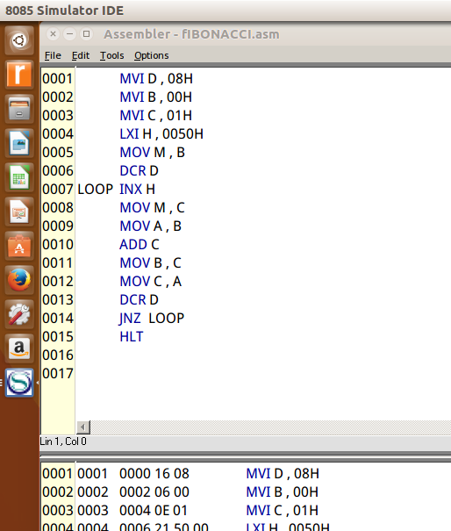 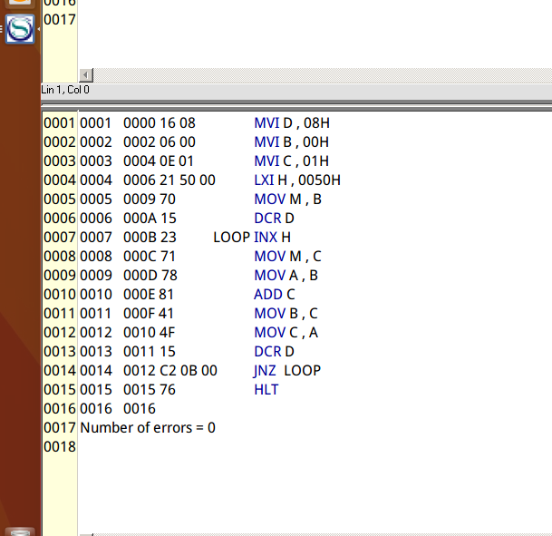

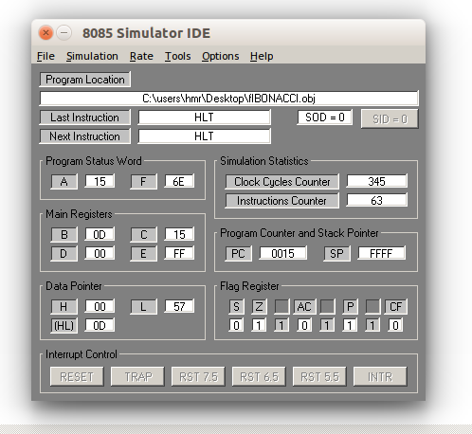

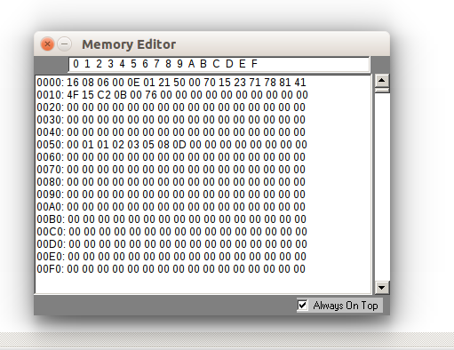

**Output :**

|  |  |
| --- | --- |
| **Before Execution** | **After Execution** |
| |  | | --- | | **D (Counter)** | | **08H** |  |  | | --- | | **B (Previous Number)** | | **00H** |  |  | | --- | | **C (Current Number)** | | **01H** | | |  |  | | --- | --- | | **0050H** | **00H** | | **0051H** | **01H** | | **0052H** | **01H** | | **0053H** | **02H** | | **0054H** | **03H** | | **0055H** | **05H** | | **0056H** | **08H** | | **0057H** | **0DH** | |

**Flow Chart :**

**No**

**Yes**

**Result :**

Program to Generate Fibonacci Series was implemented successfully.